PROJECT TITLE

Lead Organization (City, State), Principal Investigator Name,

Areas: 1) New Designs, or 2) Computer Tools or 3) Experiments
Total Project Cost: $ ,Cost Share %
Project Duration

EXECUTIVE SUMMARY

Summarize the objective(s) and technical approach of the proposed effort at a technical level appropriate for scientific and engineering peers.

INSTRUCTIONS for Cover Page and Executive Summary Section:

- The Project Title should be brief and descriptive of the proposed technology.
- Identify the most relevant Technical Category for the proposed technology from the “Technical Categories of Interest” in Section I.D of the FOA. Select only one Technical Category unless the FOA specifically allows applications to name multiple categories.
- Enter the estimated Total Project Cost in U.S. dollars and percentage cost share in parentheses.
- Enter the Project Duration in months.
- The Executive Summary shall not exceed 1 page in length.
- The Executive Summary may contain graphics, figures, or tables as needed to summarize the technical concept.

NOTICE OF RESTRICTION ON DISCLOSURE AND USE OF DATA

Pages [1 through__] of this document may contain trade secrets or commercial or financial information that is privileged or confidential and exempt from public disclosure. Such information shall be used or disclosed only for evaluation purposes or in accordance with a financial assistance or loan agreement between the submitter and the Government. The Government may use or disclose any information that is not appropriately marked or otherwise restricted, regardless of source.

INSTRUCTIONS FOR SECTIONS 1-5:
The cumulative length of Sections 1-5 shall not exceed 20 pages.

1. INNOVATION AND IMPACT

Describe how the proposed work offers an innovative approach to achieve the program objectives of the FOA and how it will impact the mission areas of ARPA-E.

1.1 Overall Description.
- Describe the conceptual basis for the project and how the proposed technology works with minimal jargon.
- Explain the objective(s) and performance characteristics of the proposed effort.

1.2 Potential Impact.
- Clearly identify the problem that is being solved with the proposed technology.
- Describe how the proposed effort addresses one (or more) of the “Technical Categories of Interest” from Section I.D of the FOA.
- Explain the project’s potential to be disruptive relative to the existing technology or how the project establishes a basis for new innovations.

1.3 Innovativeness.
- Describe how the proposed effort represents a new and innovative solution to the overall program challenge described in the FOA.
- Indicate the technical goals and anticipated results, using appropriate metrics, for the project. Provide a description of how the metrics were derived, citing key previous results and/or assumptions.
- Include and discuss, as appropriate, a table in which the targeted performance of the proposed technology is compared with the “Technical Performance Targets” in Section I.E of the FOA and with other competing or emerging technologies that might achieve the FOA Technical Performance Targets.
  - For Projects in Area 1 (New Designs), include the variables in M1, M2 and LCOE that are expected to be most significantly affected by the new design, an estimate of how much each will change, and a brief justification for each. In addition, include one page with the plot of Metric Space from Tab: “2b. Proposed Design Plot”, in the ATLANTIS Metric Space Workbook named ATLANTIS_MetricSpaceWorkbook.xlsx, which is available on ARPA-E eXCHANGE (https://arpa-e-foa.energy.gov/). Also, include the description and justification for the parameters used to calculate M1, M2 and LCOE using the Tab: “2c. Summary of Changes” (See Appendix 1).
  - For Projects in Area 2 (Computer Tools): include a list of the elements (from Section I.4.b, items e1 – e11) that you propose to enhance, and, for each, a description of how your proposed concept represents an enhancement over the relevant existing tool(s). Include both the critical elements, e1 through e5, and the four (or more) remaining secondary elements, e6 to e11 that the concept will enhance.
  - For Projects in Area 3 (Experiments): describe the intelligent real-time system that you propose to develop and include a list of the data (from Section I.4.c, items d1 – d4) and scenarios (from Section I.C.4.a, operational modes O1 – O5) that you propose to collect.

INSTRUCTIONS for the Innovation and Impact Section:
- The Innovation and Impact Section may include figures, tables, and graphics.
- The suggested length of the Innovation and Impact Section is 4 pages.

2. PROPOSED WORK

Describe and discuss for the proposed effort the technical background and approach, the R&D tasks, and the key technical risks. This Section should justify the proposed approach as being appropriate to achieve the project’s objective(s).

2.1 Approach.
- Describe the technical approach and how this approach will achieve the proposed project objective(s).
- Discuss alternative approaches considered, if any, and why the selected approach is most appropriate for the identified objective(s).
- Describe the background, theory, simulation, modeling, experimental data, or other sound engineering and scientific practices or principles that support achieving the project objective(s). Provide specific examples of supporting data and/or appropriate citations to the scientific and technical literature.

2.2 Technical Risk.
- Identify potential technical issues and risks, e.g., the approach requires a never-before-demonstrated fabrication technique or greater-than-previously-demonstrated sub-component performance, etc.
- Describe appropriate mitigation techniques and plans, if any, for each identified issue and risk.

2.3 Schedule.
- Provide a schedule for the proposed effort by major tasks, including major milestones or Go/No-Go decision points as appropriate. (A Gantt chart is recommended.)

2.4 Task Descriptions.
- Identify and provide a full technical description for each main task in the proposed effort.
- Discuss the reason the identified tasks are appropriate and sufficient for the identified approach.
- Describe the key technical milestones and how these define the critical path for successful completion of the task.
- Indicate how completion of each task relates to reducing technological uncertainty and achieving the overall project objective(s).

INSTRUCTIONS for the Proposed Work Section:
- The Proposed Work Section may include figures, tables, and graphics.
- The suggested length of the Proposed Work Section is 7 pages.

3. TEAM ORGANIZATION AND CAPABILITIES

Describe and discuss the, organization, capabilities, and management of the team and how these enable successful execution of the proposed effort.

3.1 Organization.
- Indicate roles and responsibilities of the organizations on the proposed Project Team, e.g., subrecipient, consultant, subcontractor, or lead organization for each of the project tasks. Include relevant organization charts and teaming organization charts, as applicable.
- Identify Key Personnel, describe how their qualifications relate to the proposed effort, and indicate their roles and responsibilities for each of the project tasks.
- Identify previous collaborative efforts among team members if relevant to the proposed effort.
- Describe the compatibility of the proposed management plan with the control co-design / concurrent engineering approach, including multi-disciplinary collaboration and coordination mechanisms across institutions; and
- Include a plan for collaboration amongst team members as well as with other ATLANTIS teams.

3.2 Capabilities, Facilities, Equipment, and Information.
- Identify capabilities of the Applicant or proposed Project Team, e.g., relevant experience, previous or current R&D efforts, or related government or commercial projects, that support the proposed effort.
- Identify all required facilities, equipment, and information for the proposed effort and discuss their adequacy and availability.
- Indicate any key equipment that must be fabricated or purchased.

INSTRUCTIONS for the Team Organization and Capabilities Section:
- This Section may include figures, tables, and graphics.
- The suggested length of the Team Section is 3 pages.

4. TECHNOLOGY TO MARKET

The significant impact sought by ARPA-E depends upon successful projects finding a path to large-scale adoption. ARPA-E projects are not required to achieve commercial deployment by the end of the project period, but the agency asks the Applicant to define a reasonable path for the proposed technology toward commercial adoption.

4.1 Technology to Market Strategy.
- Describe how the proposed technology is expected to transition from the lab to commercial deployment, including a description of the eventual product, potential near- and long-term market entries, likely commercialization approach (startup, license, etc.), specific organizations expected to be involved in the transition (partners, customers, etc.), and the commercialization timeline.
- Discuss manufacturing, cost, and scalability risks associated with the technology.
- Describe anticipated resource needs for the next phase of development following the end of the ARPA-E project.
- Explain why the proposed research is not being pursued by industry today.
- Discuss the anticipated roles for the proposed research team in the commercialization of the technology.
- Projects in second fundamental area (Computer Tools) must indicate in their submission whether the new computer tools will be available to project team members, other ATLANTIS teams and the public in general. The projects must also describe the commercial model intended for the new computer tools, either as an open-source, free-license, commercial-license, or others.
- Projects in the third fundamental area (Experiments) must indicate in their submission what operational data, from both laboratory prototypes and full-scale real-world commercial systems, will be made available to project team members, other ATLANTIS teams and the public in general. Please describe how this data will be made available.

4.2 Intellectual Property.
- Describe existing intellectual property, if any, that will be used to develop the new intellectual property; and
- Discuss new intellectual property and data that is anticipated to be created as part of this effort, if any.

INSTRUCTIONS for the Technology to Market Section:
- The Technology to Market Section may include figures, tables, and graphics.
- The suggested length of the Technology to Market Section is 2 pages.
5. BUDGET

Indicate the budget, in US dollars, and provide a high-level budget summary, demonstrating that the budget is reasonable and appropriate for the proposed effort.

5.1 Budget Breakdown.

Provide in tabular form following the template give below, a breakdown of the project budget by entity and major task in US dollars.

Task Name | [Prime] | [Sub #1] | [Sub #2] | [Sub #3] | [Sub #4] | Total
[Task #1]
[Task #2]
[Task #3]
[Task #4]
Total

Replace “Prime” with name of the primary (lead) entity and “Sub #n” with the name of the sub-recipient or sub-contractor entities, if applicable. Task names should clearly correspond to major tasks listed in Section 2.4. Expand or contract the table as needed to add/subtract entities (columns) or tasks (rows).

5.2 Budget Summary.

Provide a high-level summary for the project by major budget category, including at least these three:
- Key Personnel and technical staff to be utilized (e.g., scientists, engineers, technicians, postdocs, graduate students, etc.)
- Equipment
- Materials and Supplies

5.3 Cost Share.

Provide a description of the cost share by value of the contribution (in dollars) and percentage of the Total Project Cost (TPC):
- List each source of cost share, the type of contribution (cash or in-kind), the value of the contribution (in dollars), and the value as a percentage of TPC.
- For all in-kind contributions, provide a detailed description of the contribution and its relevance to the project objectives

INSTRUCTIONS for the Budget Section:
- The Budget Section may include figures, tables, and graphics.
- The suggested length of the Budget Section is 1 pages.

6. BIBLIOGRAPHIC REFRENCES

Provide a list of references appropriate to Sections 1-5.

INSTRUCTIONS for the Bibliographic References Section:
- Only bibliographic information may be contained in the references. No additional text or commentary is allowed.
- There is no page limit for the Bibliographic References Section, which is outside of the overall 20-page limit for Sections 1-5.

7. PERSONAL QUALIFICATION SUMMARIES

A Personal Qualification Summary (PQS) is required for the PI and all other Key Personnel. Each PQS must include a description of the following only:
- Education and training
- Employment history
- Awards and honors
- A list of no more than 10 peer-reviewed publications related to the proposed project
- A list of no more than 10 other peer-reviewed publications demonstrating capabilities in the broad field
- A list of no more than 10 non-peer-reviewed publications and patents demonstrating capabilities in the broad field

INSTRUCTIONS for the Personal Qualification Summaries Section:
- Each Personal Qualification Summary is limited to 3 pages in length and there is no page limit for this Section, which is outside of the 20-page limit for Sections 1-5.
- Curriculum Vitae should not be submitted.

Appendix 1 (Area 1 New Designs Submissions Only):

- Plot of Metric Space from Tab: “2b. Proposed Design Plot”

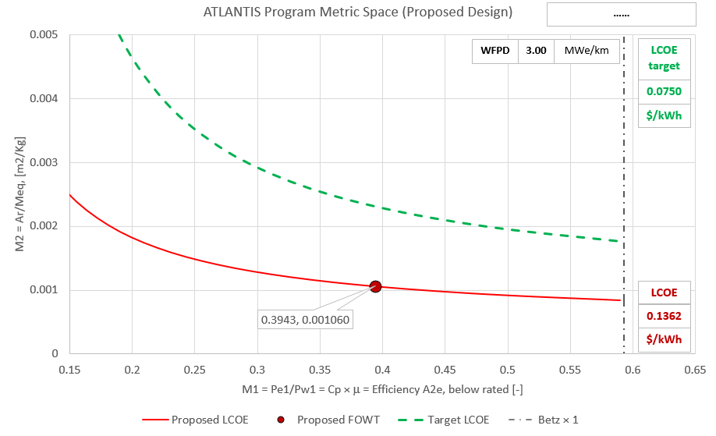

- Description and Justification for the parameters used to calculate the M1 and M2 metrics and the LCOE isoline from Tab: “2c. Summary of Changes”

Cell number | Corresponding variable | Description of change made | Brief justification of change
H9  (EXAMPLE ONLY) | Mass of Rotor Blades | New value is 1/3 of previous value | We propose a new blade design that …
F16 - L16  (EXAMPLE ONLY) | XYZ (NEW) | Added a new required component, XYZ, and included its mass (##), ft (##), fm (##), and fi (##) | XYZ is required for this design, but it will enable reduction in mass elsewhere in the system…

INSTRUCTIONS for Appendix 1:
- Appendix 1 is limited to 2 pages in length which is outside of the 20-page limit for Sections 1-5.
- Appendix 1 is limited to only applicants who are submitting to Area 1: New Designs Submissions only.
- Appendix 1 must include a Plot of Metric Space and the Description and Justification of the parameters as referenced.

TECHNICAL VOLUME TEMPLATE
INSTRUCTIONS

CONTENT REQUIREMENTS (See Section IV.D of the FOA for Content Requirements):
- The Technical Volume template may be used to prepare Technical Volumes for Full Applications.
- Applicants should ensure the accuracy of their Technical Volume by reviewing and/or printing prior to the Full Application submission.
- ARPA-E may not review or consider noncompliant and/or nonresponsive Full Applications (see Section III.C of the FOA).
- Unrelated concepts and technologies should not be consolidated into a single Full Application.
- Confidential, proprietary, or privileged information should be indicated by including in the header and footer of every page the following language: “Contains Confidential, Proprietary, or Privileged Information Exempt from Public Disclosure.” In addition, the cover sheet of the Technical Volume must also include the disclaimer provided in Section VIII.E of the FOA, and every line and paragraph containing proprietary, privileged, or trade secret information must be clearly marked with double brackets or highlighting. See Section VIII.E of the FOA for additional information on marking confidential information.
- Applicants must provide sufficient citations and references to the primary research literature to justify the claims and approaches made in the Technical Volume. ARPA-E and reviewers may review primary research literature in order to evaluate applications. However, ARPA-E and reviewers are under no obligation to review cited sources (e.g., Internet websites)
- Delete these template instructions and delete the prompts in each of the section above prior to submitting Full Applications.

FORMAT REQUIREMENTS (See Section IV.D of the FOA for Format Requirements):
- Technical Volumes must be submitted in Adobe PDF format, be written in English, use black 12 point or larger Times New Roman font (except in figures and tables), use 8.5 inch by 11 inch paper, be single-spaced, and have margins no less than 1 inch on every side.
- Technical Volumes must not exceed the maximum page lengths specified for each section of the Technical Volume in Section IV.D of the FOA. Full Applications in Area 1 (New designs) are allowed two additional pages for Appendix 1 that contains a plot of the Metric Space for the new design, and the description and justification for the parameters used to calculate the M1 and M2 metrics and LCOE isoline. If applicants exceed the maximum page length, ARPA-E will review only the authorized number of pages and disregard any additional pages.
- The ARPA-E assigned Control Number, Lead Organization Name, and Principal Investigator’s (PI’s) Last Name must be in the upper right hand corner of the header of every page. Page numbers must be included in the footer of every page.

